TRENDS IN FIRST CLASS CRICKET IN NEW ZEALAND
FROM 1907/08
INTRODUCTION
This analysis was first prepared in 1991 when at that time there was a great deal of discussion over the merits or
otherwise of four day cricket and whether its re-introduction to the domestic competition would be of benefit to
New Zealand cricket.
The two main reasons given in advocating change were:
that it would make the adjustment from first class cricket to test cricket easier for the players
that competition for the Shell Trophy would be a fairer indication of the standards of the teams as the extra playing
hours would reduce the number of declarations required to produce outright decisions.
It was therefore decided to analyze the first class cricket competition, the Plunket Shield, from 1945/46 in the expectation
that certain trends might emerge which could help in the debate and any decisions to be made.
The statistics were updated in April 2018 to include the period from 1907/08 to 1939/40. The five years from 1940/41
to 1944/45 have not been included as there was no competition for the Plunket Shield competition due to the Second World War.
At the conclusion of the 1906/07 season, the New Zealand Cricket Council awarded the Plunket Shield to Canterbury
based on their performances that year. The following season Auckland made the first challenge and in a three day match defeated Canterbury by an innings and135 runs to win the Plunket Shield.
All three provinces made a challenge in the 1909/10 season and from then on until the 1914/15 season there were three to
four challenge matches played each year. Due to the advent of the First World War there was no first class cricket played in the
three year period from 1915/16. The competition for the Plunket Shield began again in the 1918/19 season but there had been concern for some time that the challenge system was not ideal. After consultation with the four major associations the
New Zealand Cricket Council decide on a league competition where all associations would play each other and the Shield
would be awarded on the number of matches won.

HISTORY
1.Duration of Games
From the 1907/08 season many matches were often classified as unlimited, some were listed to be of four days duration
but the majority were completed within three days. From 1927/28 to 1939/40 matches were played over four days, but again many
were finished within three days. After the 2nd World War had ended the Plunket Shield competition began in the 1945/46 season
and matches were continued over the four days duration.
Nine years later in the 1954/55 season the change was made back to three day matches, a decision that had been preceded
by much debate highlighted by Arthur Carman's comments in the 1952/53 Almanack when "he felt certain that a great deal of the negative and aimless batting and bowling which is too often witnessed at present is due to the idea that there is too much time available. With a three day limit more attractive play would almost certainly result, necessarily so if a bid was made for victory."
Four day cricket was played over 24 hours, ie 6 hours/day, but at the time of the change to three day cricket the playing
hours were extended by half an hour each day, so that in effect the total time available was 19 1/2 hours. Those hours
remained in force until the 1966/67 season when by beginning games at 10am, a seven hour playing day was established,
21 hours total time.
The reintroduction of four day cricket in 1992/93 initially maintained the 7 hour playing day, 28 hours in total, but the
following season 1993/94, saw a reduction in daily playing time to 6 1/2 hours/day or 26 hours total time but could be longer
if the required number of overs had not been achieved.
In effect the move to four day cricket from 1993/94 created an extra five hours of play with a minimum extra 64 overs
of play. Over the period from 1907/08 until 2017/18 there were 103 seasons of Plunket Shield cricket with 49 seasons of four day cricket and 69 seasons of three day cricket.

2. Provinces
Central Districts were introduced to first class cricket in 1950/51 and were followed by Northern Districts in the
1956/57 season.

3. Points
1907/08 to 1914/15: Challenge system. No points.
1918/19 to 1929/20: Outright wins one point and if a tie in victories achieved, the Plunket Shield decided on the
best net runs per wicket.
1930/31 to 1957/58 : outright decisions 8 points, a 1st innings win 4 points and a 1st innings loss 2 points
1958/59 to 1969/70 : outright decisions10 points, a 1st innings win 5 points and a 1st innings loss 1 point, 3 points for
a 1st innings lead when beaten outright.
1970/71 to 1981/82: bonus points introduced for 1st innings, but outrights points remained at 10. Over this 12 period
a number of modifications were made to the bonus points system before their final elimination
at the end of the 1981/82 season.
1982/83 to 1993/94: outright decisions 12 plus an extra 4 points for leading on the 1st innings. No points for a 1st innings
loss.
1994/95 to 1996/97: outright decisions 8 points plus an extra 4 points for a 1st innings win. No points for a 1st innings loss.
1997/98 to 2002/03: outright decisions 6 points, 1st innings lead 2 points. No points for a 1st innings loss.
2003/04 to 2010/11: a change was made to allow a maximum of 8 points if an outright and 1st innings points were achieved.
2 points for a 1st innings win but an outright loss.
2011/12 to 2017/18: Bonus points were introduced. 12 points for an outright win, 6 points for a tie. No points for a first
innings win or loss. Also available were batting points at 250, 300, 350 and 400 runs and bowling points
at 3, 5, 7,and 9 wickets for the first 110 overs of the first innings.

4. Overs.
Six balls overs have been used for all years except for a period of eight years from 1918/19 until 1926/27, five years
from 1937/38 until 1943/44 and 11 years from 1968/69 to 1978/79 when 8 ball overs were tried. ie of the 106 seasons up to
2017/18 eight ball overs were used for 24 seasons.
A limitation on the number of overs to be bowled in the 1st innings was introduced for six years from 1976/77 to 1981/82 inclusive. The first three years there were 75 8 ball overs and the last three years there were 100 6 ball overs.
Penalty points for slow over rates were introduced in 1979/80 and various formats tried for seven years. Initially a rate of
18 overs/hour over the entire course of the match was required but after one year the requirement was reduced to 17 overs/ hour.
In 1983/84 the requirement was changed to be applied over the course of the whole season, but after a further 3 years
under this system the concept of penalty points applying to slow over rates was abolished at the conclusion of the 1985/86 season.
For 3 years from 1986/87 to 1988/89 there was a requirement for a minimum of 119 overs to be bowled in a day’s play,
but with many games continuing 45 to 60 minutes beyond the scheduled close of play, this rule had no effect on maintaining
a reasonable over rate.
In 1989/90 in an endeavour to overcome this problem, the minimum daily rate was reduced to 112 overs but an additional
requirement of bowling 17 overs/hour over the course of a match was also introduced. Over rate point penalties were also
reintroduced. However after 1 year the regulation was again changed with the new rate being 17 overs/hour over the season.
In 1993/94 an additional over rate penalty of $1,000 was introduced for each over under 17 per hour.
From 1998/99 to 2009/10 the minimum daily rate was reduced to 100 overs (15 overs per hour) but with no reduction
for change of innings, fall of wickets or first drinks interval in any session. Penalties for slow over rates were now only financial
and were calculated round by round rather than over the whole season.
Below 15 overs per hour but not below 14. $1,000.00
Below 14 overs per hour. $2,000.00
In 2010/11 the only change was to require 100 overs to be bowled in a day but with no reduction for a change of innings.
In 2011/12 the only change was to require 97 overs to be bowled in a day. Penalties for slow over rates were unchanged.
From 2015/16 to 2017/18 a change was made to require 96 overs to be bowled in a day. Penalties for slow over rates were unchanged

5. Number of Games.
A new sponsorship by the Shell Oil Company in 1975/76 saw an increase in the number of rounds each season from
five to seven with the Grand Final concept tried for the first three years. An increase to an eight round competition began in 1982/83 with an extension to 10 rounds introduced in 1989/90.
In 1992/93 four day cricket was introduced in a limited manner, the 1st round of five matches was played over three days followed
by a second round of three matches played over four days and then a final.
In 1993/94 one round of five matches was played over four days followed by two semi-finals and a final.
In 1994/95 seven rounds of four day matches were played followed by a final.
In 1995/96 five rounds of four day matches were played followed by a final.
In 1996/97 eight rounds of four day matches were played followed by a final.
In 1997/98 to 1999/00 five rounds of four day matches were played followed by a final with the final in 1998/99 and 1999/00
being played over five days.
In 2000/01, 2001/02, 2002/03 ten rounds of four day matches were played with no final.
In 2003/04 eight rounds of four day matches were played with a final played over four days.
In 2004/05 to 2008/09 the final was played over five days with the number of overs in a day set at 90. The top qualifier
hosted the final (except in 2008/09 when it was played at Lincoln), and the second placed team had to win outright to take
the title.
From 2009/10 to 2017/18 the competition was extended to ten rounds with no final played

RESULTS 1ST CLASS CRICKET
1. Note that the blue line black marker in the graphs indicate the period of three day cricket and the black line red marker
indicates four day cricket.
2. Innings are only counted if they last longer than 10 overs.

Graph 1
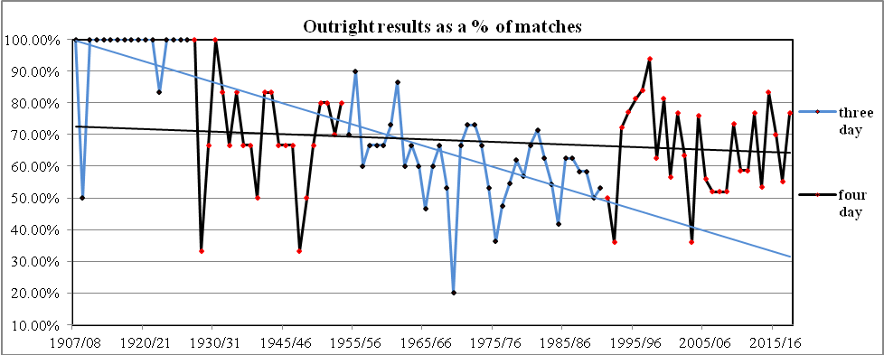
This graph analyses the number of outrights achieved as a percentage of matches played in each year. In the first twenty
years from the 1907/08 season there were only two seasons when no outrights decisions occurred. Over the next period
until 1992/93 there was clearly a steady decline in outright results which was a major reason for the push for four day
cricket.
Their introduction showed an initial rapid increase in the number of outrights to reach a peak of 94% in the
1997/98 season. This result was affected to some extent by a wet season where there were a number of contrived results.
In contrast the poor weather of 1998/99 saw more declarations but fewer outrights, in fact a number of matches did not
even achieve a first innings result.
Over the 48 seasons of four day cricket only 13 years have seen more than 70% of matches ending in an outright
decision and the overall average is 65%. This is only slightly higher than the average of 60% of outrights over the 55 years
of three day cricket.

Graph 2.
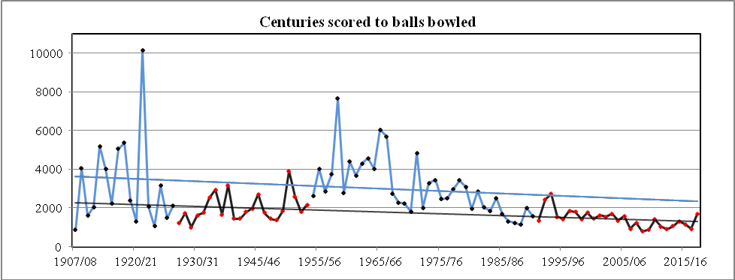
This graph analyses the number of centuries scored to the total number of balls bowled each year. In the first twelve years
few centuries were scored but from 1922/23 they became more frequent with 13 scored in the 1923/24 season. The ratio was
reasonably static over the next thirty years until the reintroduction of three day cricket in 1954/55 saw the number of
centuries reduce quite substantially. However this trend changed around the early 1980’s and the number of centuries has
increased since then to hover around a century for every 1000 balls bowled. The highest ratio was achieved in 2008/09 when 62 centuries were scored at the new figure of 791 balls bowled for each century scored. The following season 66 centuries were scored at a slightly higher ratio but in 2017/18 only 29 centuries were scored at the worst ratio since 2003/04.

Graph 3.
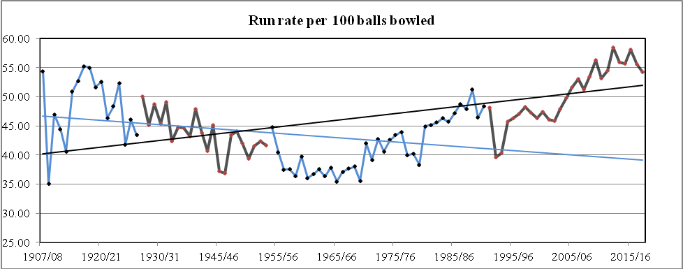
This graph indicates the rate at which runs have been scored per 100 balls bowled. Normally the run rate is shown in runs
per over but due to the 24 year period when eight ball overs were in play the 100 ball rate is used in this graph.
In eleven of the first sixteen years the run rate was over 50 equivalent to 3 runs per six ball overs. From 1920/21 the
rate falls until it reaches its lowest rate in 1969/70 at 35. Since that time there has been gradual increase with the rate really
taking off with the introduction of the Shell Cup competition in 1980/81. The 1988/89 season produced a very high rate when
it exceeded 50 runs/100 balls for the first time since 1927/28.
Surprisingly the first two years of 4 day cricket in 1992/93 and 1993/94 saw a slowing of the run rate. However since
then the rate has increased and from the 2005/06 season the rate has never gone below 50 runs/100 balls with the highest
rate reached in 2012/13 at 58 equivalent to 3.5 runs per over. 2015/16 season was also high at 58 but the last two seasons
have seen a slight fall to 55 and 54 respectively.

Graph 4
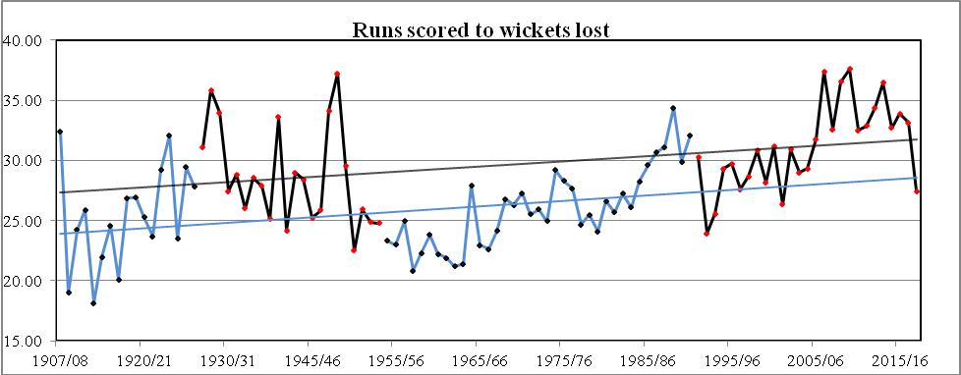
This graph analyses the number of runs scored for every wicket to fall. The initial period from 1907/08 shows a ratio
well under 25 runs for every wicket to fall. Over the period from 1928/29 the ratio stayed for most of the time between
25 and 30 until the 1950/51 season when the rate fell below 25 and remained at that low figure for most of the next
30 years. The increase began in the early 1980’s but there was no great change until the 2006/07 season when it jumped to
37 runs. The low figure for the 2017/18 season at 27 was in line with most of the other low statistics for that year.

Graph 5.
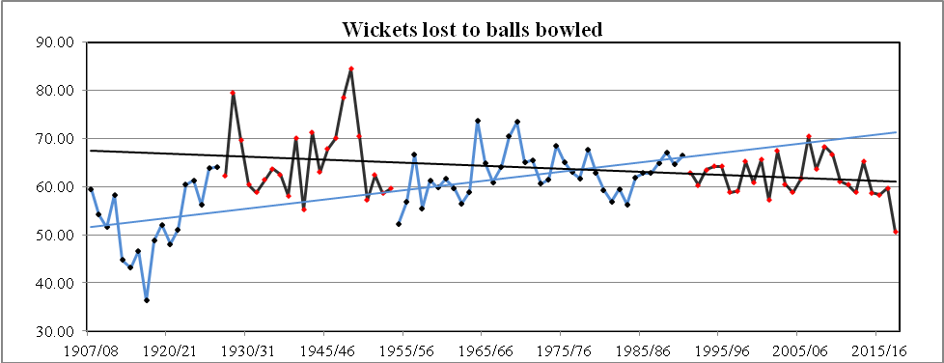
This graph analyses the number of balls bowled for every wicket taken. In the first 12 years a wicket was taken on average
at every 50 balls but the introduction of four day cricket saw the rate rise to reach a high of 84 in 1948/49, a wicket
every 14 overs. With the change to three day cricket the rate dropped slightly to a 65 average and continued when four day
cricket was reintroduced in 1992/93. Over the past 26 seasons of four day cricket the rate has fluctuated between 57 and
70 balls per wicket with only six seasons with a rate above 65 balls. In general the trend over the period of four day cricket
has seen wickets fall more frequently. The 2017/18 season saw a dramatic change to a rate of 50 balls to every wicket lost,
a figure not seen since 1920/21.

Graph 6.
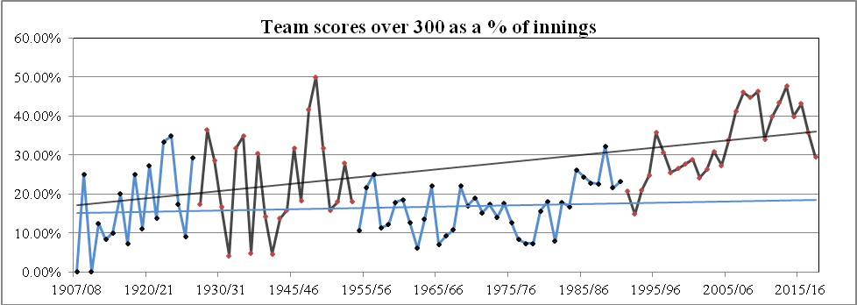
This graph shows the number of team scores over 300 as a percentage of innings played. Over the first 32 years there was
much variation from a high of 36% in 1928/29 to below10% in ten of the seasons. The early period of four day cricket
shows that there were a number of high scores with a high of 50% of innings in 1948/49. This was followed by a rapid
drop to the low of 6% in 1962/63. The six year period from 1976/77, when there was a limit of 600 balls allowed to be
bowled in the first innings, saw the percentage fall below 10%. Since that time scores over 300 have risen and over
the last twelve years, nine seasons have seen 40% or more innings reach that figure. The 2017/18 season drop to 30%
follows the trend for that year.

Graph 7.
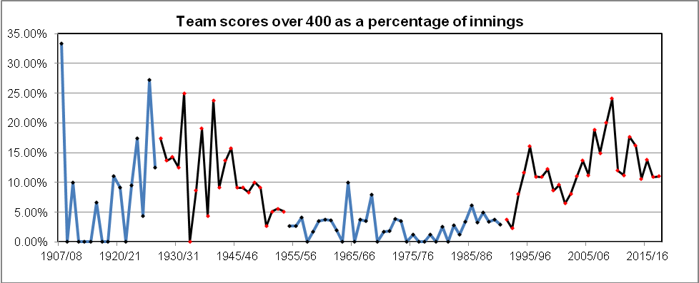
This graph shows that initially there were very few scores over 400 until the 1925/26 season when the percentage reached
28 and remained high until the 1936/37 season. From then on the percentage dropped considerably through the 60’s, 70’s
and 80’s and it was not until 1994/95 that the percentage of 15% was reached. However in general the move to four day
cricket has seen the rate rise, more particularly after the 2005/06 season and it reached a high of 24% in 2009/10. Of interest
to note that the high number of scores over 300 in 2013/14 did not translate to a higher number of scores over 400, only 16%.

Graph 8
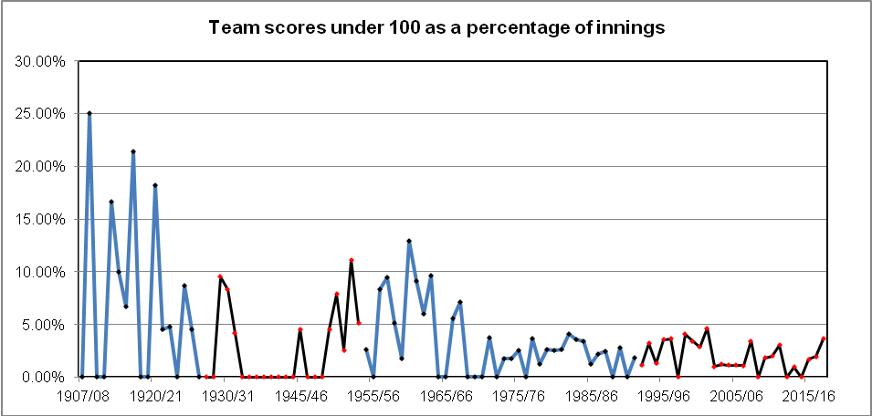
This graph shows the percentage of team scores under 100. In the period from 1907/08 until 1972/73, 61 seasons, there
was a marked variation from the high of 20% in 1908/09 to 28 seasons when no low scores were registered. Over the last
27 years the trend has remained on a downward line with an average of just over one score under 100 each season. The one
anomaly was in 2001/02 when five scores were registered under 100, 4.63%.

Graph 9
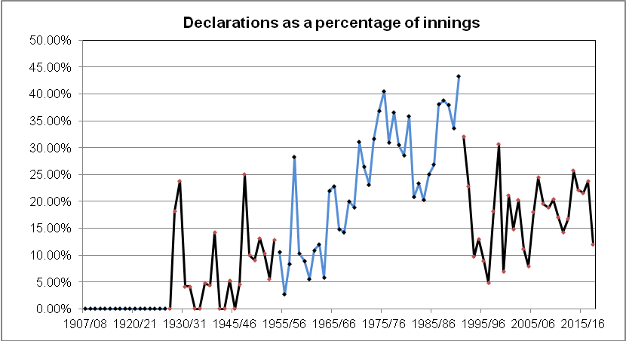
This graph shows the number of declarations as a percentage of innings. In the first twenty years declarations were not needed
as most matches were timeless and many finished within three days. From the 1945/46 season there was generally little change
until 1964/65 when a gradual increase in the number of declarations began. The six year period from 1976/77 saw a limitation
of overs on the first innings to gain bonus points and this had an effect on when declarations were made.
From the 1992/93 season there was a reduction in declarations, particularly with the advent of four day cricket. The last
13 years of four day cricket shows an average of 20% of innings having a declaration compared to 31% for the last 13 years of
three day cricket. ie 358 declarations to 258 declarations.
Over the four of the past five seasons the percentage has stabilized around 21% of innings.

Graph 10
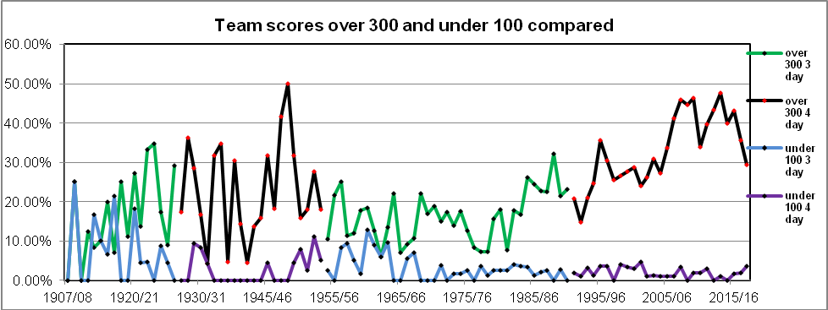
This graph compares team scores in excess of 300 and less than 100 as a percentage of total innings. In the early years the percentage gap between the two remained constantly below 10% with the worst season in 1962/63 where there were identical
scores, only three scores over 300 and three under 100. It was not until the introduction four day cricket that the gap widen appreciably. The greatest difference came in the 2013/14 season with 50 scores over 30 at 47% and only one score under
100. The 2017/18 season reversed the trend with only 32 scores over 300 and a high of four scores under 100.

Graph 11.
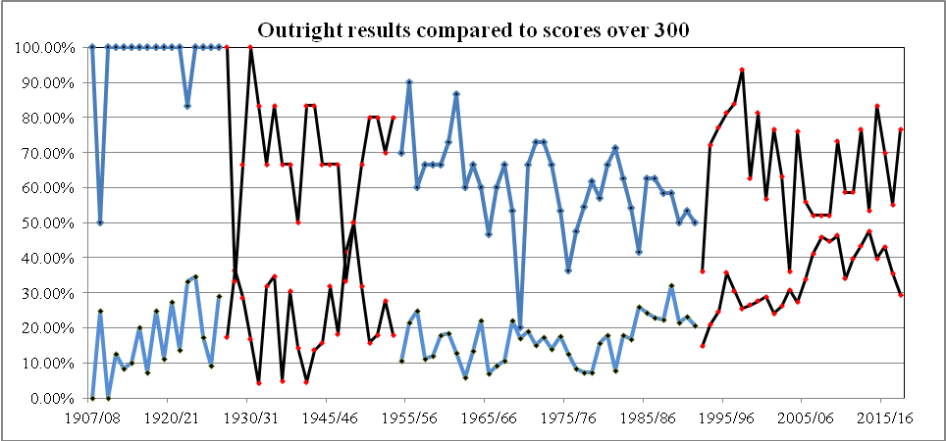
This graph looks at the relationship between outrights achieved and team scores over 300. Outright decisions are in upper line
and closer the two lines merge indicates that more frequent scores over 300 reduce the number of outright results. The 1961/2 season shows the greatest different result with outrights occurring in 87% of games and scores over 300 low at 14%. However
from 2003/04 there is a noticeable change with the increase in 300 plus scores reducing the number of results. The 2013/14 season saw a low difference at 6%. 53 % of matches had an outright decision whilst scores over 300 were at 47%.

Graph 12.
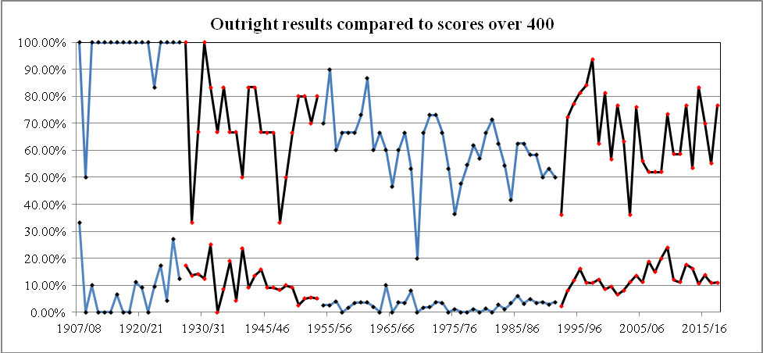
This graph looks at the relationship between outrights achieved and team scores over 400. Compared with graph 11 it is of
interest to note that in the early years scores of 400 had no effect on the number of outrights results. The 1955/56 season shows
the largest difference with outrights occurring in 90% of games and yet scores over 400 were low at 3%. The 1969/70 season
was unusual in that only 20% of matches had a decision and there were no scores over 400. In contrast the 1997/98 season had
a high with 93% of outright matches whilst scores over 400 were only at 11%. It is only from 2003/04 with nine outright decisions, 36% of matches, and nine scores over 400, 11%, does the gap begins to narrow.

Graph 13.
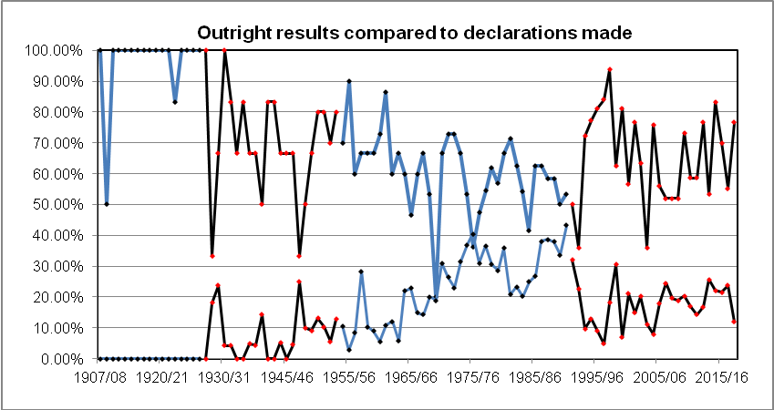
This graph compares the effect of declarations on achieving outright decisions. In the early period very few declarations were required to achieve outright decisions. However this totally changed during the period between 1970 and 1992 when the high
number of declarations produced fewer results, the standout season being 1969/70 when there were only three outrights in 15 matches and 11 declarations in the 54 innings. The second period of four day matches saw the number of results increase with a
reduced number of declarations. In 1999/00 81% of outrights and 7% of declarations produced one of the largest differences followed by the 2004/05 season which had a difference of 66%. Since then the difference percentage ratio has been static
averaging around the 50% mark.

Graph 14.
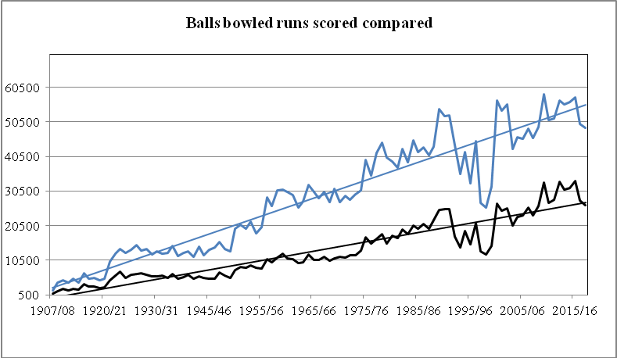
This graph shows how there was a reduction in runs scored and balls bowled after the introduction of 4 day cricket
in 1992/93 and it was only with the introduction of two rounds of four day cricket in 2000/01 that increased the
opportunity for more first class cricket. The reduction to eight rounds of four day cricket from 2003/04 to 2007/08
saw the total numbers align to that of the last period of three day cricket. The trend over the 103 seasons shows that
there has been an increase in the runs to balls ratio from very little difference to the largest in 2009/10 when there
were 58,570 balls bowled to 33,016 runs scored.

Graph15
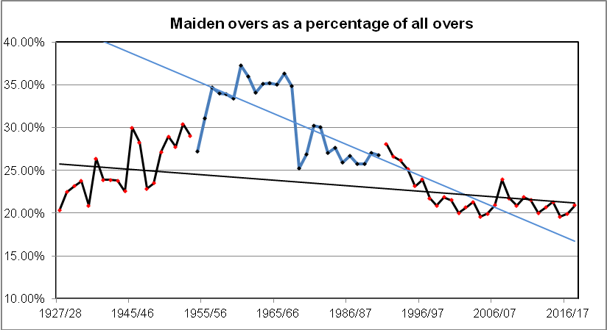
This graph shows the relationship between the maiden overs bowled during the six ball over periods. The eight ball over
period has not been included. The highest percentage of maiden overs came in the 1960/61 season when 37% of the overs
bowled were maidens. More recently maiden overs have declined, particularly with the introduction of four day cricket
matches in 1992/93. The lowest percentage during the four day cricket period came in 2015/16 when 19.5% of overs
were maidens.

Graph 16.
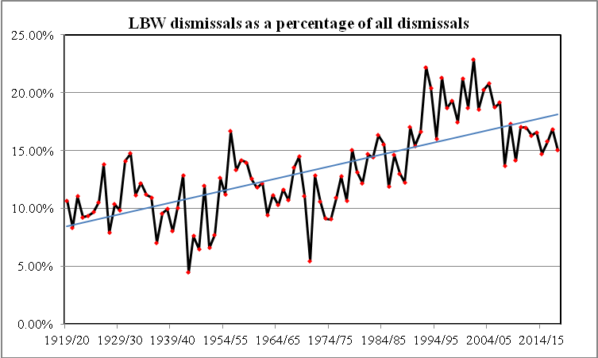
This graph shows the percentage of lbw dismissals from 1919/20. The lbw decision is the most controversial decision
in cricket, first appearing in the laws of 1774. The initial law was formed when batsmen began using their pads to protect
the stumps and it specifically noted that the legs were involved and the ball had to be pitched in line with the wickets.
Later the law was changed to mean any part of the body.
In 1937, in a response to an increasing amount of pad play, the law was changed to enable a batsman to be dismissed
even if the ball landed outside the line of the off stump but still hit the batsman in line with the wickets. In 1972 another change
was made to allow a decision for dismissal if the batsman did not make a genuine attempt to hit the ball and no longer was
the impact required to be in line with the stumps. It was added to the Laws of Cricket in 1980.
The percentage of lbws sharply increased and a study in 2011 showed that in English county cricket, the proportion of lbw wickets in the 1920s was around 11% and this rose to 14% in the 1930s. It had almost reached 19% by 2010. Simon Hughes, the former English County cricketer and analyst on British cricket television for a number of years, believes the introduction of the DRS in 2009 changed the thinking of umpires. He writes that deliveries that may have been given not out in earlier years now with the Hawk Eye technology are given out and in effect has widen the target for bowlers by almost a balls width and height.
In New Zealand the trend had been initially similar with the percentage around 10% in the early years before the frequency increases around the 1978/79 season reaching a high of 23% in 2001/02. But strangely since the 2007/08 season the percentage has dropped significantly to an average of 16% and certainly within New Zealand first class cricket raises doubt on Simon Hughes’s theory.

Graph 17
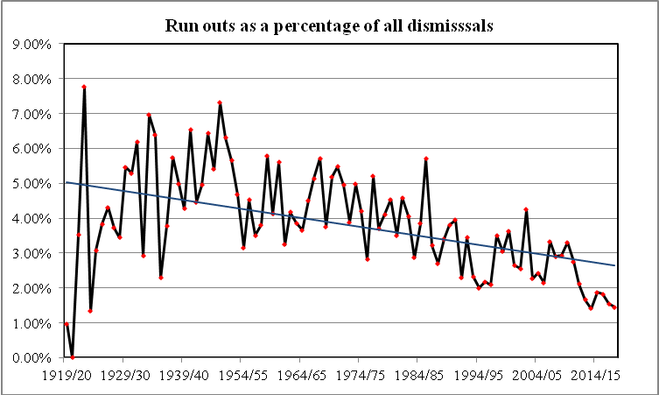
This graph shows the percentage of run out dismissals and quite clearly shows a significant decline from the high of
7.8% in 1922/23 to the low of 1.41% in the 2013/14 season, ie 12 out of 851wickets to fall. The drop over the last seven
years is particularly noticeable with the percentage well below the 2% mark in the period.

Graph 18
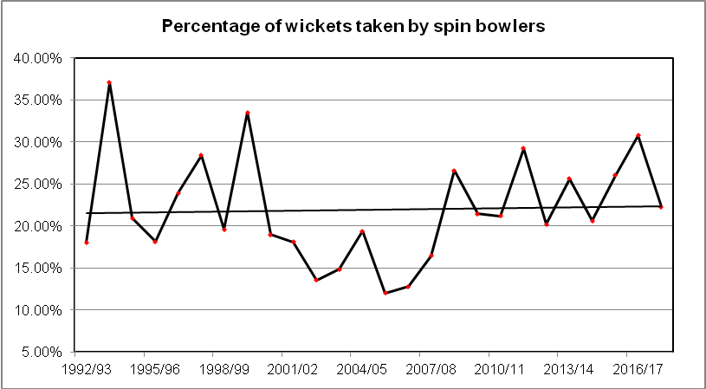
This graph over the period of four day cricket looks at those bowlers who have taken more than 10 wickets in each season
and then compares the percentage of wickets taken by spin bowlers with the other bowlers. There was a high of 37% in
1993/94 when nine spin bowlers took a total of 150 wickets compared to 16 bowlers of other types of delivery who took 255 wickets.
There was a period eight years from 2000/01 when the percentage of spin bowler wickets never reached 20% and the lowest figure of 12% came in the 2005/06 season when the five spin bowlers only took 77 wickets while 29 other bowlers took
535 wickets.
Since that time the success and use of spin bowlers has improved and over the last ten years the average has reached
24% of the wickets to fall.

Graph 19
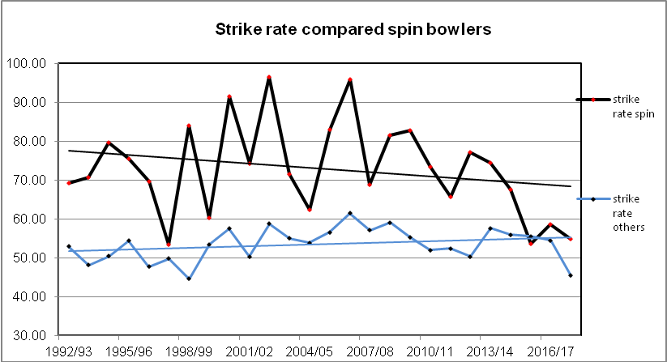
This graph compares the strike rate of spin bowlers with all other bowlers who have taken at least 10 wickets in a season. It shows an improved rate for spin bowlers from the high of 97 balls per wicket in the 2002/03 season,
a wicket every 16 overs, to a rate of 53 in the 2015/16 season.
Of interest the strike rate of other bowlers has altered very little although notably the 2017/18 season realised
the best rate of 45 over the 26 seasons.

First Class, One Day and 20.20 Matches Played
 | Matches |  |  |  | Days
 | FC | Min Overs |  | FC | 50 Over | 20.20 | Total
1988/89 | 24 | 8,568 |  | 72 | 15 |  | 87
1989/90 | 30 | 10,710 |  | 90 | 18 |  | 108
1990/91 | 30 | 10,710 |  | 90 | 18 |  | 108
1991/92 | 30 | 10,080 |  | 90 | 18 |  | 108
1992/93 | 25 | 9,520 |  | 85 | 18 |  | 103
1993/94 | 18 | 8,064 |  | 72 | 34 |  | 106
1994/95 | 22 | 9,856 |  | 88 | 34 |  | 122
1995/96 | 16 | 7,168 |  | 64 | 34 |  | 98
1996/97 | 25 | 11,200 |  | 100 | 34 |  | 134
1997/98 | 16 | 7,168 |  | 64 | 34 |  | 98
1998/99 | 16 | 6,500 |  | 65 | 34 |  | 99
1999/00 | 16 | 6,500 |  | 65 | 34 |  | 99
2000/01 | 30 | 12,000 |  | 120 | 34 |  | 154
2001/02 | 30 | 12,000 |  | 120 | 32 |  | 152
2002/03 | 30 | 12,000 |  | 120 | 32 |  | 152
2003/04 | 25 | 10,000 |  | 101 | 32 |  | 133
2004/05 | 25 | 10,050 |  | 101 | 32 |  | 133
2005/06 | 25 | 10,050 |  | 101 | 32 | 7 | 140
2006/07 | 25 | 10,050 |  | 101 | 32 | 16 | 149
2007/08 | 25 | 10,500 |  | 101 | 32 | 16 | 149
2008/09 | 25 | 10,500 |  | 101 | 32 | 25 | 158
2009/10 | 30 | 12,000 |  | 120 | 27 | 31 | 178
2010/11 | 30 | 12,000 |  | 120 | 27 | 31 | 178
2011/12 | 30 | 11,640 |  | 120 | 27 | 31 | 178
2012/13 | 30 | 11,640 |  | 120 | 27 | 32 | 178
2013/14 | 30 | 11,640 |  | 120 | 27 | 32 | 179
2014/15 | 30 | 11,640 |  | 120 | 27 | 33 | 180
2015/16 | 30 | 11,520 |  | 120 | 27 | 33 | 180
2016/17 | 30 | 11,520 |  | 120 | 27 | 33 | 180
2017/18 | 30 | 11,520 |  | 120 | 27 | 33 | 180
The above table indicates the maximum and minimum numbers of days of cricket available since 1988/89 season.

10 Wickets or more taken in season
 | Spin bowlers |  | Other bowlers
1992/93 | 6 |  | 24
1993/94 | 9 |  | 16
1994/95 | 6 |  | 22
1995/96 | 4 |  | 19
1996/97 | 7 |  | 21
1997/98 | 5 |  | 15
1998/99 | 5 |  | 10
1999/00 | 7 |  | 16
2000/01 | 9 |  | 31
2001/02 | 8 |  | 24
2002/03 | 6 |  | 24
2003/04 | 5 |  | 25
2004/05 | 6 |  | 24
2005/06 | 5 |  | 29
2006/07 | 5 |  | 23
2007/08 | 5 |  | 22
2008/09 | 9 |  | 23
2009/10 | 8 |  | 25
2010/11 | 6 |  | 21
2011/12 | 10 |  | 25
2012/13 | 8 |  | 30
2013/14 | 9 |  | 24
2014/15 | 7 |  | 25
2015/16 | 7 |  | 29
2016/17 | 8 |  | 25
2017/18 | 8 |  | 26

When making the comparison over the last 26 years with spin bowlers and other types of bowlers who have taken more than
10 wickets in a season it shows that:
the spinners have bowled 235,886 balls and taken 3,329 wickets at an average of 33.76 and at a strike rate of a wicket every eleven overs.
The other bowlers over the same period have bowled 648,197 balls and taken 12,059 wickets at an average of 26.33 and at a strike rate of a wicket every nine overs. 21% of the total wickets to fall were taken by spin bowlers.
There has been a marked increase in the use and success of spin bowlers over the past ten years to the point in the 2016/17 season where four of the top five wicket takers were spinners. AY Patel 44 wickets, TS Nethula 43 wickets, IS Sodhi 40 wickets,
SC Kuggeleijn 34 wickets and TD Astle 31 wickets. Again in 2017/18 AY Patel was the leading wicket taker with 48 wickets and other successful spinners were JS Patel with 36 wickets, IS Sodhi 28 wickets and MD Craig 20 wickets.
Looking only at the last three seasons the percentage of wickets taken by the spin bowlers rises to 26% which is certainly
in line with the International trend of greater use and success and the strike rate of 55 is closer to the pace bowlers at 51 than at any other period during the four day matches.

Outrights Under or Over 336 Overs
Year | Under | Over | Total | % Under to Total
1992/93 | 6 | 3 | 9 | 66.67%
1993/94 | 6 | 7 | 13 | 46.15%
1994/95 | 9 | 8 | 17 | 52.94%
1995/96 | 6 | 7 | 13 | 46.15%
1996/97 | 12 | 9 | 21 | 57.14%
1997/98 | 14 | 1 | 15 | 93.33%
1998/99 | 7 | 3 | 10 | 70.00%
1999/00 | 7 | 6 | 13 | 53.85%
2000/01 | 13 | 4 | 17 | 76.47%
2001/02 | 18 | 5 | 23 | 78.26%
2002/03 | 7 | 12 | 19 | 36.84%
2003/04 | 8 | 1 | 9 | 88.89%
2004/05 | 12 | 7 | 19 | 63.16%
2005/06 | 9 | 5 | 14 | 64.29%
2006/07 | 6 | 7 | 13 | 46.15%
2007/08 | 10 | 3 | 13 | 76.92%
2008/09 | 7 | 6 | 13 | 53.85%
2009/10 | 11 | 10 | 21 | 52.38%
2010/11 | 11 | 6 | 17 | 64.71%
2011/12 | 15 | 2 | 17 | 88.24%
2012/13 | 15 | 8 | 23 | 65.22%
2013/14 | 7 | 9 | 16 | 43.75%
2014/15 | 12 | 13 | 25 | 48.00%
2015/16 | 13 | 8 | 21 | 61.90%
2016/17 | 8 | 8 | 16 | 50.00%
2017/18 | 19 | 4 | 23 | 82.60%
Total | 268 | 162 | 430 | 62.32%

The question arises what percentage of matches have lasted into the fourth day. Taking 336 overs as the standard,
being the minimum required to be bowled when the competition was played over three days, the following figures
indicate that out of a total of 430 outrights achieved playing 4 day cricket, 268 could have been completed within
three days ie 61%. Twelve of the last fourteen years indicate a trend to early finishes with the 2002/03 season
reversing that trend most emphatically
The one positive to emerge from the years of four day cricket has been the number of outright results obtained with a
reduced need for declarations. But with so many outrights (61%) finishing within 336 overs the question arises has the
increased availability of cricket been put to good advantage, has the cricket played been of better quality, has it helped the
players more easily bridge the step up to International cricket, has it encouraged greater use of spin bowlers, have the
players enjoyed the game more, have spectators shown greater interest, has the competition been more interesting and
more closely fought, have the teams been of more equal strength.

Yearly comparison from 1996/97
The chart below summarises the trend in first class cricket

Summary | Matches | Results | Results% | Inns | r/o | 300+ | 300% | 100- | wkt | r/wkt | Century | 100/balls | LBW%
1996/97 | 24 | 21 | 87.50% | 82 | 2.82 | 25 | 30.49% | 3 | 767 | 27.63 | 24 | 1876 | 18.64%
1997/98 | 16 | 15 | 93.75% | 55 | 2.89 | 14 | 25.45% | 0 | 456 | 28.65 | 15 | 1806 | 19.30%
1998/99 | 16 | 10 | 62.50% | 49 | 2.84 | 13 | 26.53% | 2 | 395 | 30.81 | 19 | 1355 | 17.47%
1999/00 | 16 | 13 | 81.25% | 58 | 2.78 | 16 | 27.59% | 2 | 523 | 28.17 | 18 | 1767 | 21.22%
2000/01 | 30 | 17 | 56.67% | 104 | 2.85 | 30 | 28.85% | 3 | 866 | 31.12 | 39 | 1456 | 18.71%
2001/02 | 30 | 23 | 76.67% | 108 | 2.77 | 26 | 24.07% | 5 | 940 | 26.36 | 33 | 1628 | 22.87%
2002/03 | 30 | 19 | 63.33% | 99 | 2.75 | 26 | 26.26% | 1 | 825 | 30.92 | 36 | 1545 | 18.55%
2003/04 | 25 | 9 | 36.00% | 81 | 2.88 | 25 | 30.86% | 1 | 706 | 28.98 | 24 | 1774 | 20.11%
2004/05 | 25 | 19 | 76.00% | 88 | 2.99 | 24 | 27.27% | 1 | 784 | 29.30 | 34 | 1355 | 20.79%
2005/06 | 25 | 14 | 56.00% | 89 | 3.09 | 30 | 33.71% | 1 | 742 | 31.77 | 29 | 1576 | 18.73%
2006/07 | 25 | 13 | 52.00% | 90 | 3.18 | 37 | 41.11% | 1 | 690 | 37.37 | 53 | 917 | 19.13%
2007/08 | 25 | 13 | 52.00% | 87 | 3.07 | 40 | 45.98% | 3 | 723 | 32.57 | 37 | 1242 | 13.69%
2008/09 | 25 | 13 | 52.00% | 85 | 3.21 | 38 | 44.71% | 0 | 718 | 36.53 | 62 | 791 | 17.27%
2009/10 | 30 | 22 | 73.33% | 108 | 3.38 | 50 | 46.30% | 2 | 878 | 37.60 | 66 | 887 | 14.12%
2010/11 | 30 | 17 | 56.66% | 100 | 3.19 | 34 | 34.00% | 2 | 834 | 32.48 | 36 | 1416 | 17.03%
2011/12 | 30 | 17 | 56.66% | 98 | 3.27 | 39 | 39.80% | 3 | 854 | 32.88 | 50 | 1031 | 16.98%
2012/13 | 30 | 23 | 76.66% | 113 | 3.51 | 49 | 43.36% | 0 | 963 | 34.39 | 62 | 913 | 16.30%
2103/14 | 30 | 16 | 53.33% | 105 | 3.35 | 50 | 47.62% | 1 | 851 | 36.44 | 52 | 1067 | 16.78%
2014/15 | 30 | 25 | 83.33% | 113 | 3.34 | 45 | 39.82% | 0 | 958 | 32.69 | 43 | 1307 | 14.72%
2015/16 | 30 | 21 | 70.00% | 116 | 3.49 | 50 | 43.10% | 2 | 989 | 33.88 | 50 | 1154 | 15.77%
2016/17 | 30 | 16 | 53,33% | 110 | 3.34 | 36 | 32.73% | 2 | 838 | 33.16 | 54 | 943 | 16.83%
2017/18 | 30 | 23 | 76.66% | 109 | 3.25 | 32 | 29.36% | 4 | 965 | 27.44 | 29 | 1683 | 15.03%
Total | 582 | 379 | 65.12% | 2047 | 3.13 | 729 | 34.04% | 39 | 17265 | 31.99 | 864 | 1266 | 17.56

Number Of Players Used In First Class Cricket
1984/85 | 107 | 1985/86 | 101 | 1986/87 | 92 | 1987/88 | 110
1988/89 | 100 | 1989/90 | 107 | 1990/91 | 110 | 1991/92 | 115
1992/93 | 106 | 1993/94 | 116 | 1994/95 | 118 | 1995/96 | 94
1996/97 | 119 | 1997/98 | 104 | 1998/99 | 111 | 1999/00 | 104
2000/01 | 110 | 2001/02 | 107 | 2002/03 | 112 | 2003/04 | 108
2004/05 | 110 | 2005/06 | 109 | 2006/07 | 116 | 2007/08 | 108
2008/09 | 116 | 2009/10 | 124 | 2010/11 | 122 | 2011/12 | 122
2012/13 | 122 | 2013/14 | 113 | 2014/15 | 114 | 2015/16 | 128
2016/17 | 116 | 2017/18 | 127

The increased number of first class matches in 2009/10 saw a rise in the number of players used to a new high with the
increase in International cricket competition affecting the composition of provincial teams.

